Malmesbury Carnival Procession: Saturday 5th September 2026
Let’s make Malmesbury Carnival Procession Bigger and Better! Anyone can enter, and all sorts of entries and new ideas are welcome. In previous years we’ve had lorries, tractors & trailers, walkers, wheelchairs, cyclists, cars and even a Shetland Pony!
To enter, please complete the details below, sign and return the form. Entry is free.
Please fill in all relevant fields in the THREE boxes below
Categories | Definition | Please tick applicable category | Is the vehicle articulated? | No. of people in entry (roughly) | Prize
Motorised Vehicle Adults | Pubs, Licensed Sports and Social Clubs, Businesses etc. |  | Yes / No |  | £100
Motorised Vehicle – Younger people | Youth Organisations, Schools, Playgroups etc. |  | Yes / No |  | £100
Walking/Wheels | Any walking entry, individuals or groups or wheeled entries |  | n/a |  | £50*
Booked Support Acts/Bands etc | Booked bands, dance troops etc |  | n/a |  | n/a
Wackiest entry will receive Bob Browning Award and £30 (kindly donated by Rob and Jackie Peel)
Most outstanding entry in the spirit of Carnival will receive the Paul Dove Award and £30 (kindly donated by Lisa Huntly)
*The Steve Cox Cup is awarded to the best walking entry
Carnival may need to alter Prize Categories depending on entries on Procession Day so particular efforts can be recognised.
ABOUT YOU
NAME/THEME OF YOUR ENTRY:
Name of Company, Club, Group, Family or Individual
Entry Manager name
Entry Manager address
Entry Manager mobile
Entry Manager email
LEGAL DECLARATION
I/we acknowledge that I have Public Liability Insurance cover and all other relevant Insurance Cover for entry into the Procession. Malmesbury Carnival and its Trustees do not accept any liability whatsoever for any loss or damage including damage caused to or by any persons, animals or vehicles.
As the organiser, you are signing on behalf of all entrants in your group, confirming you have read this document and will ensure that everyone in the group understands and fulfils the Terms and Conditions set out in this entry form.
Signed: Date:
Please return form to: procession@malmesburycarnival.co.uk or post to Carnival Procession, c/o Paul Overton, 15 St Mary’s Street, Malmesbury, Wilts, SN16 0BJ

OUTLINE SCHEDULE
16:00 | - Road Closure of Park Road  - Motorised vehicles to assemble in Park Road facing Procession route (to avoid manoeuvring in a crowded area)  - Other Categories to assemble in the Football Club off Gloucester Road (SN16 9JS)  - First Aid in position on Park Road
16.30 | Judging commences
17:00 | Road closures across remainder of Procession route
17:30 | Judging finishes. Prize awards and press photos.
18:00 | Procession starts
19:30 | Procession finishes
20:00 | Roads re-open
PROCESSION ROUTE AND FACILITIES
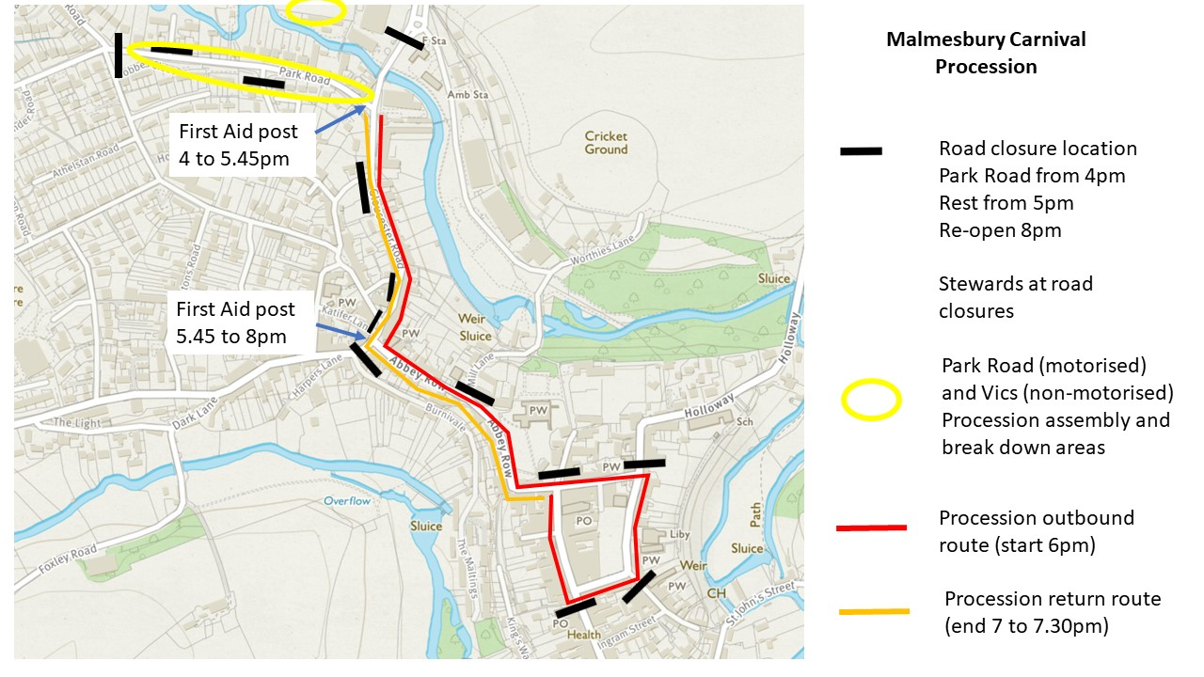
The Procession route covers approx. 1.5 miles including up and down hill sections, and tight corners, in particular the very tight left turn by the Market Cross (top of High St left on to Gloucester St). The Procession is expected to last no more than 1.5 hours. Additional time may be required for float assembly and breakdown before and after Procession. Please ensure you, those under your care and your float are adequately prepared for this, and that vehicles have sufficient fuel!!
Car Parking. The Station Road car park will be closed for the fun fair. Replacement parking is available at the Dyson car park off Beutell Way, SN16 9JU. This is a tarmac surface with marked capacity for ~100 cars. Temporary parking is for Saturday only and cars must be removed on Saturday. The Weaver family have again kindly offered their large field off Holloway, SN16 9JL, what3words: ///scrap.passes.thickens), this will be marked by temporary signage.
First Aid. First Aid post located at Park Road from 4.30 to 5.45pm, then The Triangle from 5.45 to 8pm.
Toilets. Available in the Football Club and Riverside Centre

HEALTH AND SAFETY
Carnival Committee is committed to the safe delivery of Procession for the several thousand members of the public who attend, for all float Entrants and for everyone else impacted by Procession.
Wheel Walkers. Motorised vehicles must include their own Wheel Walkers. The role is to keep people, especially children, away and out of danger from the vehicle and ensure the driver stops immediately in the event of danger. (Children may run out to retrieve coins even when vehicles are passing). The Wheel Walkers must wear distinctive sashes (supplied by the Carnival committee) and have no other role, e.g. not carrying collection buckets.
- Articulated motorised vehicles– 6 Wheel Walkers. One on each corner and one on each side between traction unit and trailer
- Other motorised vehicles
  - All non-articulated lorries. 4 Wheel Walkers – one on each corner
  - Cars and vans. 2 Wheel Walkers - one on each front corner
- We also ask drivers to think of the risk of being struck and distracted by thrown coins. Consider keeping vehicle windows closed, or use netting protection
Coin collection. Most years our fantastic community donates ~£3,000 during Procession!! But we need to be careful about thrown coins. In the past children have collected fallen coins from the road between moving vehicles; and people, drivers and vehicles have been struck by thrown coins. So please help us as we will be encouraging donation only into buckets carried by volunteers walking alongside the floats!! But please, from now on limit the use of nets and buckets on the floats!! Your help will help ensure we can continue to safely run the Carnival Procession!!
Fire Prevention. No re-fuelling of vehicles or generators at any location associated with the Procession. No naked flames or pyrotechnics
Crowd Safety. Nothing to be ejected from the float which may compromise the safe enjoyment of the Procession by others
Post Procession. float break-down ONLY in Park Rd (last road to re-open). No floats to park in Gloucester Rd
Please also note the following:
- Entrants are responsible for the safe design of their Entries
- Please discuss with us any unusual risks associated with your Entry BEFORE the day!!
- Feel free to discuss with us any additional needs that you or those under your care may require
- For motorised vehicles, the vehicle must comply with Road Traffic Legislation (inc. Section 40A of the Road Traffic Act 1988 (which covers dangerous vehicle offences); taxed, licensed and registered with DVLA; driver to have appropriate driving licence and be covered by appropriate insurance)
- Flat bed vehicles and trailers must have a form of safety railing to prevent falls from the flatbed
- Electrical equipment must be installed and certified by a competent and qualified person.
- The tyres, lights and brakes must conform to legal requirements
- Drivers of motorised floats must be able to get their vehicle and passengers round this route safely

RISK ASSESSMENT
As part of your approach, you must carry out a risk assessment for your entry. Below is a guide of some things to consider:
- Vehicles moving in close proximity to the public
- The safety of people carried on the float and how to avoid slips, trips and falls getting on, when on, and getting off the float
- The float should be robust enough that stuff won’t fall off (potentially injuring people) while the float goes up and down hills, round tight corners, or when braking is required
- Generators: Only diesel generators are permitted
- Electrical risk from generators, particularly if 240v cables and connections are used
- Fire risk, including if combustible material is present (fuel for generators, hay and straw etc.). Appropriate fire extinguishers must be sealed, tagged and tested within the previous 12 months
- the risk presented by any moving parts
- Any gas appliances must carry a Gas Safe certificate – we cannot accept entries without this. Any gas cylinders must be appropriately stored on the vehicle
- Fumes (including exhausts)
- Max float height of 4.5m due to overhead power lines halfway up the Gloucester Rd hill
- Impact of loud music, other loud noises, sirens, flashing lights, crowds, pauses in Procession movement etc.
- Weather. Make sure your float will be as safe as possible in the prevailing weather conditions.
- Alcohol - please stay legal!
- There may be other risks that your innovative design requires you to consider!!
INSURANCE
Please ensure your insurance covers you for entry into the Procession
STEWARDS
We always need more volunteer Stewards – can you provide any volunteer Stewards? email us on procession@malmesburycarnival.co.uk
We really want as many floats in Procession as possible, so please email us with any queries well before 20th August at procession@malmesburycarnival.co.uk
SUSTAINABILITY
We’d love to maximise the sustainability of Carnival, so wherever possible, please: Reduce, Re-use, recycle!!

Please return form to: procession@malmesburycarnival.co.uk or post to Carnival Procession, c/o Paul Overton, 15 St Mary’s Street, Malmesbury, Wilts, SN16 0BJ

